

General Sir John Kotelawala Defense University

Department of Electrical, Electronics & Telecommunication Engineering

Machine Learning

ET 4103

Assignment – 01

Linear Regression with a Single Variable

Index No : D/ENG/22/0120/ET

Name : M. A. E. Wijesuriya

Intake : 39

Submission Date : 20/06/2025

Q1. Utilize the given Jupyter notebook for Linear Regression with a single variable. Comment on the code and the output of the program, explaining utilized Machine Learning concepts where necessary

Code with Explanation:

(text in *italics,* along with any graphs or tables,are the output of the preceding code segment)

# File Location: The file we want to access is currently placed in the current working directory of Python.

import os

from google.colab import drive

drive.mount('/content/drive') # Grants Colab access to Google Drive in order to retrieve the data files

%cd "/content/drive/MyDrive/ML_files"

*Mounted at /content/drive*

*/content/drive/MyDrive/ML_files*

# Import the required Libraries

import pandas as pd

import numpy as np

import sklearn

import matplotlib.pyplot as plt

path = 'ex1data1.txt'

data_path = path

data = pd.read_csv(path, header=None, names = ["x1", "y"])

data.head() # Prints the first five rows of the data

|  |  |  |
| --- | --- | --- |
|  | *x1* | *y* |
| *0* | *6.1101* | *17.5920* |
| *1* | *5.5277* | *9.1302* |
| *2* | *8.5186* | *13.6620* |
| *3* | *7.0032* | *11.8540* |
| *4* | *5.8598* | *6.8233* |

data.shape # Returns the shape of the data in the form (rows, columns)

*(97, 3)*

x1 = data['x1'] # Extracts x1 values into list

y = data['y'] # Extracts y values into list

plt.scatter(x1,y,s=30,c='r',marker='x',linewidths=1) # Prepares a scatter plot of the data

plt.xlim(min(data['x1']-1),max(data['x1']+1)) # Sets limits for the extent of the graph

plt.xlabel('Population of City in 10,000s') # Labels X axis

plt.ylabel('Profit in LKR10,000s'); # Labels Y axis

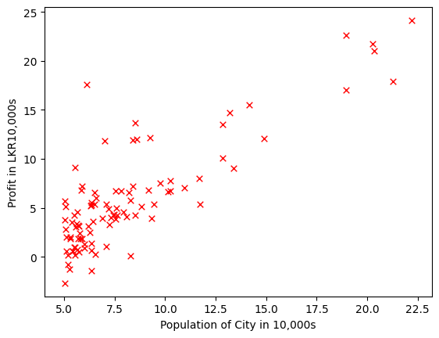

# Cost Function

m = data.shape[0]

def Cost(x,y,theta):

    J = 0

    #Hypothesis

    h = x.dot(theta)

    #Cost Function

    J = 1/(2*m)*np.sum(np.square(h-y))

    return J

data.insert(loc=0,column='x0',value=np.ones(m))

data.head()

|  |  |  |  |
| --- | --- | --- | --- |
|  | x0 | x1 | y |
| 0 | 1.0 | 6.1101 | 17.5920 |
| 1 | 1.0 | 5.5277 | 9.1302 |
| 2 | 1.0 | 8.5186 | 13.6620 |
| 3 | 1.0 | 7.0032 | 11.8540 |
| 4 | 1.0 | 5.8598 | 6.8233 |

x = data[data.columns[0:data.shape[1]-1]]

n = data.shape[1]-1

y = data[data.columns[n:n+1]]

# conversion to an np.array

x = x.values

y = y.values

m = y.shape[0]

theta_initial = np.array([[0],[0]])

Cost(x,y,theta_initial) # calculates the cost function for x, y using theta_initial

*np.float64(32.072733877455676)*

# Gradient Descent implementation

def gradientDescent(x, y, theta, alpha, num_iters):

    J_history = np.zeros(num_iters)

    for iter in np.arange(num_iters):

        h = x.dot(theta)

        theta = theta - alpha*(1/m)*(x.T.dot(h-y))

        J_history[iter] = Cost(x, y, theta)

    return(theta, J_history)

theta_initial = np.array([[0],[0]])

alpha = 0.01 # Sets the learning Rate

iterations = 1500 # Sets the number of iterations

theta, cost_history = gradientDescent(x,y,theta_initial,alpha,iterations)

theta # Prints the calculated theta value

*array([[-3.63029144],*

*[ 1.16636235]])*

cost_history # Prints the calculated cost history value

*array([6.73719046, 5.93159357, 5.90115471, ..., 4.48343473, 4.48341145,*

*4.48338826])*

# Plot of cost_history vs. iterations

plt.plot(cost_history)

plt.ylabel('J' + ' (' + r'$\theta$' +')')

# or plt.ylabel('J' + ' (\u0398)' )

plt.xlabel('Iterations')

plt.ylim(ymin = 0)

plt.xlim(0,iterations)

*(0.0, 1500.0)*

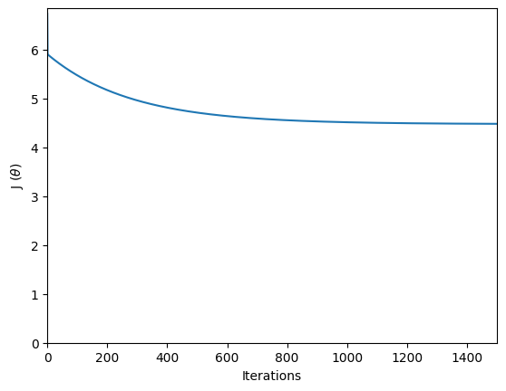

# Plots a scatter plot of the data along with the model predicted through linear regression

x_range = np.arange(min(data['x1']),max(data['x1']))

y_range = theta[0] + theta[1]*x_range

plt.scatter(x1,y,s=30,c='r',marker='x',linewidths=1)

plt.plot(x_range,y_range, label='Linear regression (Gradient descent)')

plt.xlabel('Population of City in 10,000s')

plt.ylabel('Profit in LKR10,000s')

plt.legend(loc=4);

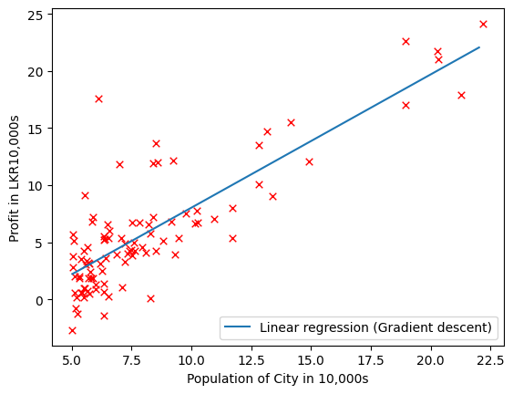

# Sklearn Implementation

from sklearn.linear_model import LinearRegression

linreg = LinearRegression()

linreg.fit(x[:,1].reshape(m,1),y)

# This plot compares directly the theoretical implementation of Linear Regression with the Built-in Scikit version

plt.plot(x_range, (linreg.intercept_ + linreg.coef_*x_range).ravel(), label='Linear regression (Scikit-learn GLM)')

plt.scatter(x1,y,s=30,c='r',marker='x',linewidths=1, alpha=0.6)

plt.plot(x_range,y_range, label='Linear regression (Gradient descent)')

plt.xlim(min(data['x1']-1),max(data['x1']+2))

plt.xlabel('Population of City in 10,000s')

plt.ylabel('Profit in LKR10,000s')

plt.legend(loc=4);

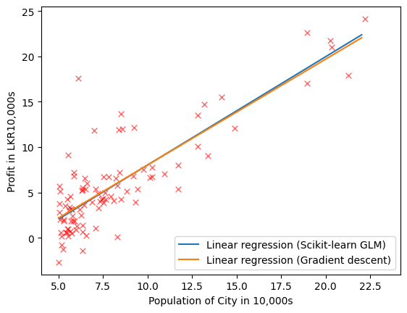

# Predict profit for a city with population of 35000 and 70000

print(theta.T.dot([1, 3.5])*10000)

print(theta.T.dot([1, 7])*10000)

*[4519.7678677]*

*[45342.45012945]*

# Create grid coordinates for plotting

B0 = np.linspace(-10, 10, 50)

B1 = np.linspace(-1, 4, 50)

xx, yy = np.meshgrid(B0, B1, indexing='xy')

Z = np.zeros((B0.size,B1.size))

# Calculate Z-values (Cost) based on grid of coefficients

for (i,j),v in np.ndenumerate(Z):

    Z[i,j] = Cost(x,y, theta=[[xx[i,j]], [yy[i,j]]])

from mpl_toolkits.mplot3d import axes3d

fig = plt.figure(figsize=(15,6))

ax1 = fig.add_subplot(121)

ax2 = fig.add_subplot(122, projection='3d')

# Left plot (Contour Plot of the Cost Function)

CS = ax1.contour(xx, yy, Z, np.logspace(-2, 3, 20), cmap=plt.cm.jet)

ax1.scatter(theta[0],theta[1], c='r')

plt.colorbar(CS,orientation='horizontal')

# Right plot (3D surface plot of Gradient Descent)

CS2 = ax2.plot_surface(xx, yy, Z, rstride=1, cstride=1, alpha=0.75, cmap=plt.cm.jet)

ax2.set_zlabel('Cost')

ax2.set_zlim(Z.min(),Z.max())

ax2.view_init(elev=30, azim=230)

plt.colorbar(CS2, orientation='vertical')

# settings common to both plots

for ax in fig.axes:

    ax.set_xlabel(r'$\theta_0$', fontsize=20)

    ax.set_ylabel(r'$\theta_1$', fontsize=20)

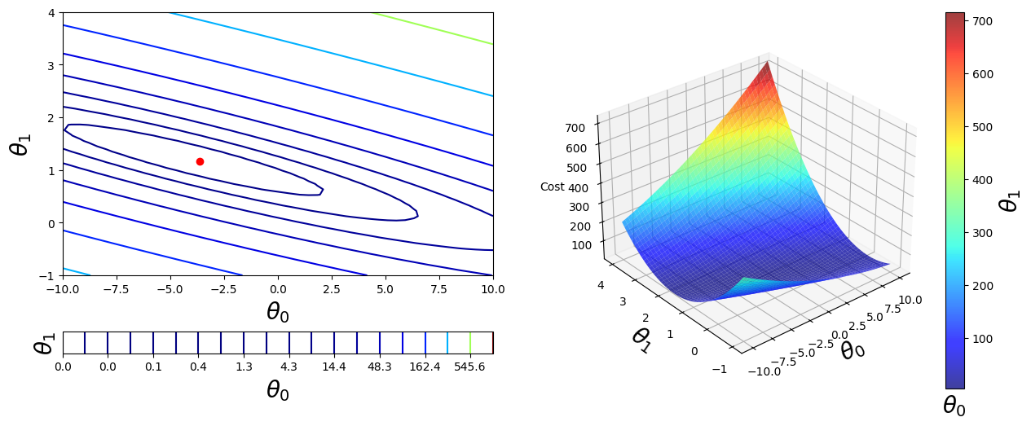

The python program given above shows an implementation of